January 2005

6663 Core Mathematics C1

Mark Scheme

Question Scheme Marks
number

1. (a) 4 (or ± 4) B1
(b) 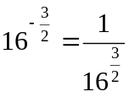 and any attempt to find 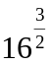 M1

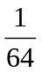 (or exact equivalent, e.g. 0.015625) (or ±) A1 (3)

3

2. (i) (a) 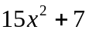 M1 A1 A1 (3)
(i) (b) 30x B1ft (1)

(ii) 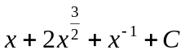 A1: 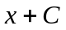, A1: +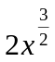, A1: +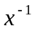 M1 A1 A1 A1(4)

8

3. Attempt to use discriminant 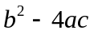 Should have no x’s M1

(Need not be equated to zero) (Could be within the quadratic formula)

144 – 4 × k × k = 0 or 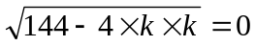 A1

Attempt to solve for k (Could be an inequality) M1

k = 6 A1 (4)

4

4. 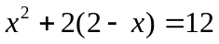 or 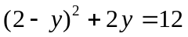 (Eqn. in x or y only) M1

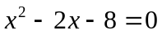 or 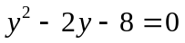 (Correct 3 term version) A1

(Allow, e.g. 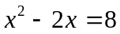)

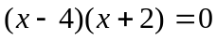 x = … or 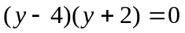 y = … M1

x = 4, x = –2 or y = 4, y = –2 A1

y = –2, y = 4 or x = –2, x = 4 (M: attempt one, A: both) M1 A1ft (6)

6

Question Scheme Marks
number

5. (a) –3, –1, 1 B1: One correct B1 B1 (2)

(b) 2 (ft only if terms in (a) are in arithmetic progression) B1ft (1)

(c) Sum = 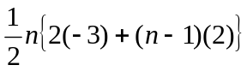 or 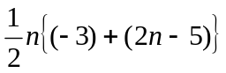 M1 A1ft

= 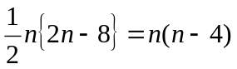 (Not just 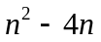) (*) A1 (3)

6

- (a) Reflection in x-axis, cutting x-axis twice. B1

(3, 2) 2 and 4 labelled (or (2, 0) and (4, 0) seen) B1

2 4 Image of P (3, 2) B1 (3)

(b)

Stretch parallel to x-axis M1

1 and 2 labelled (or (1, 0) and (2, 0) seen) A1

1 2 Image of P (1½, –2) A1 (3)

(1½, –2) 6

7. (a) 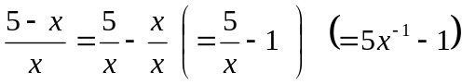 M1

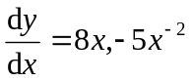 M1 A1, A1

When x = 1, 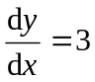 (*) A1 cso (5)

(b) At P, y = 8 B1

Equation of tangent: 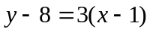 (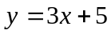) (or equiv.) M1 A1ft (3)

(c) Where y = 0, 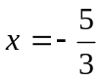 (= k) (or exact equiv.) M1 A1 (2)

10

Question Scheme Marks
number

8. (a) p = 15, q = –3 B1 B1 (2)

(b) Grad. of line ADC: m = 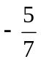, Grad. of perp. line =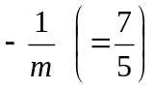 B1, M1

Equation of l: 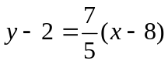 M1 A1ft

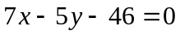 (Allow rearrangements, e.g. 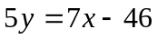) A1 (5)

(c) Substitute y = 7 into equation of l and find x = … M1

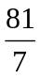 or 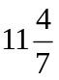 (or exact equiv.) A1 (2)

9

9. (a) Evaluate gradient at x = 1 to get 4, Grad. of normal =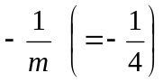 B1, M1

Equation of normal: 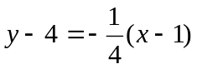 (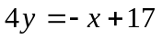) M1 A1 (4)

(b) 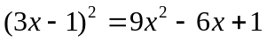 (May be seen elsewhere) B1

Integrate: 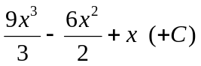 M1 A1ft

Substitute (1, 4) to find c = …, c = 3 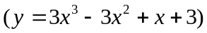 M1, A1cso (5) (c) Gradient of given line is –2 B1

Gradient of (tangent to) C is ≥ 0 (allow >0), so can never equal –2. B1 (2)

11

Question Scheme Marks
number

10. (a) 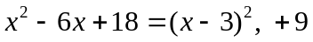 B1, M1 A1 (3)

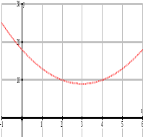
(b) “U”-shaped parabola M1

Vertex in correct quadrant A1ft

P: (0, 18) (or 18 on y-axis) B1

Q: (3, 9) B1ft (4)

(c) 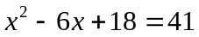 or 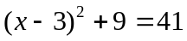 M1

Attempt to solve 3 term quadratic x = … M1

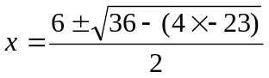 (or equiv.) A1

√128 = √64 × √2 (or surd manipulation 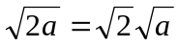 ) M1

3 + 4√2 A1 (5)

12

